EXPERIMENT NO. 5

RISK MANAGEMENT MONITORING AND MITIGATION PLAN

Aim

Develop a risk table for a University Exam Scheduling

Description

A risk table is a list of all the risks that could affect your software project. A risk is an event that is not guaranteed to happen (i.e. not 100%) that if triggered would affect your project positively or negatively. At most times, when people discuss risks in software projects, they are assuming that the risk is negative. If the risk event is triggered, i.e. comes to pass, then there is a severity associated with that event. Risks severity is typically low, medium, high, or catastrophic. You may have a strategy that would mitigate the risk. Mitigating strategies are invoked after a risk has occurred to reduce the severity of the outcome.
The risk table will at least list the following for each row:
- Risk description
- Probability
- Severity
- Mitigation strategies
- Strategies to reduce the probability

Example of one line of the risk table:
- Description: Chief architect quits during project development
- Probability: Low
- Severity: Catastrophic
- Mitigation strategy:
    - Identify developer with best architecture skills to work with chief architect
    - Identify recruiters who can find qualified architects quickly
  - Strategy to reduce probability of trigger
    - Make sure chief architect is compensated correctly
    - Make sure that the architect has good working conditions
Typical risks include:
- Schedule risk
- Key personnel risk
- Requirements risk (i.e. that the requirements are incomplete or inconsistent)
- Learning curve risk (i.e. that your resources learn new things slower than expected)
- Technical risk

A risk table provides a project manager with a simple technique for risk projection.
A sample risk table is illustrated in the next page, Figure 1.
Impact values:
l- Catastrophic
2- Critical
3- marginal
4- Negligible

A project team begins by listing all risks (no matter how remote) in the first column of the table. This can be accomplished with the help of the risk item check-lists given earlier. Each risk is categorized in the second column (e.g., PS implies a project size risk, BU implies a business risk). The probability of occurrence of each risk is entered in the next column of the table. The probability value for each risk can be estimated by team members individually. Individual team members are polled in round-robin fashion until their assessment of risk probability begins to converge.

Figure 1:Sample risk table
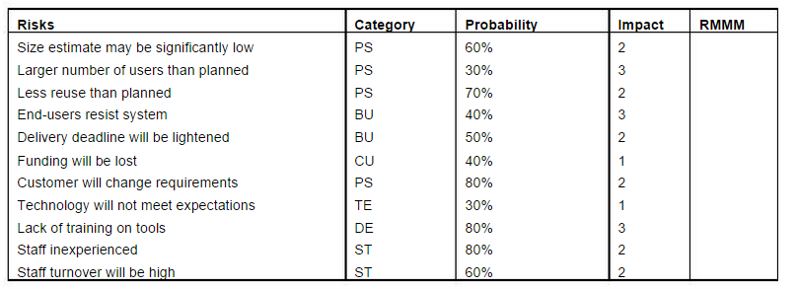

Next, the impact of each risk is assessed. Each risk component is assessed using the characterization presented in the sample risk table, and an impact category is determined. The categories for each of the four risk components - performance, support, cost, and schedule - are averaged to determine an overall impact value.

Figure 2: Risk and management concern

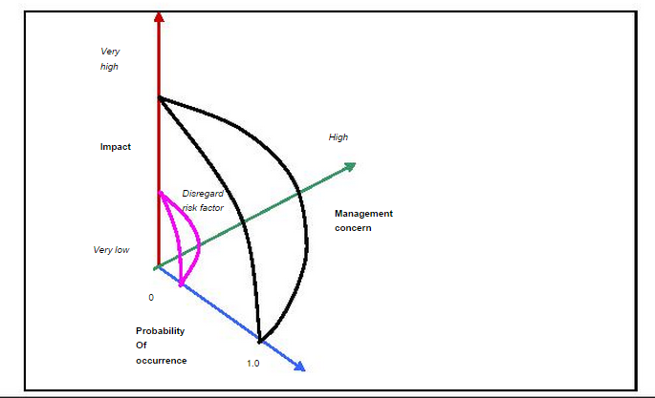

Once the first four columns of the risk table have been completed, the table is sorted by probability and by impact. High-probability, high-impact risks percolateto the top of the table, and low-probability risks drop to the bottom. This accomplishes first order risk prioritization. The project manager studies the resultant sorted table and defines a cutoff line. The cutoff line (drawn horizontally at some point in the table) implies that only risks that lie above the line will begiven further attention . Risks that fall below the line are re-evaluated toaccomplish second-order prioritization.

Referring to Figure 2, risk impact and probability have a distinct influence onmanagement concern. A risk factor that has a high impact but a very low probability of occurrence should not absorb a significant amount of management time. However, high-impact risks with moderate to high probability and low-
impact risks with high probability should be carried forward into the risk analysis steps that follow.

All risks that lie above the cutoff line must be managed. The column labeled RMMM contains a pointer into Risk Mitigation, Monitoring and Management Plan or alternatively, a collection of risk information sheets developed for all risksthat lie above the cutoff.

Conclusion

Risks | Category | Probability | Impact | RMMM
Clients may not want to utilize system | BU | 48% | 3 | 1.44
Lightened Deadlines | BU | 59% | 2 | 1.18
Reduced Funding | CU | 41% | 1 | 0.41
Lack of Training | DE | 86% | 3 | 2.58
Project Size Estimate maybe wrong | PS | 64% | 2 | 1.28
More Users than Planned | PS | 31% | 3 | 0.93
Changing Requirements | PS | 85% | 2 | 1.7
Inexperienced Staff | ST | 89% | 2 | 1.78
May not meet Expectations | TE | 32% | 1 | 0.32

